Fivestreet Business Overview

* Fivestreet is a software tool that is sold to brokers and agents to manage the leads and distribute the lead to the agents within their brokerage**.**
* FiveStreet comes under a revenue generation tools like Top Producer, Ressio, ListHub, realsuite for MOVE.



**Concept of FiveStreet**

* Fivestreet is a licensed product for brokers and agents to manage the leads and distribute the lead to the agents within their brokerage.
* Top producer is kind of CRM system, marketing system for agents and brokers to manage the relationship with them.
* Fivestreet sits in front of TopProducer, it is a lead aggregator for sources like (realtor.com, trulia.com etc.)
* Fivestreet gets leads from more than 150+ vendors and capable to train or we can say entertain more 3000+ types of template.

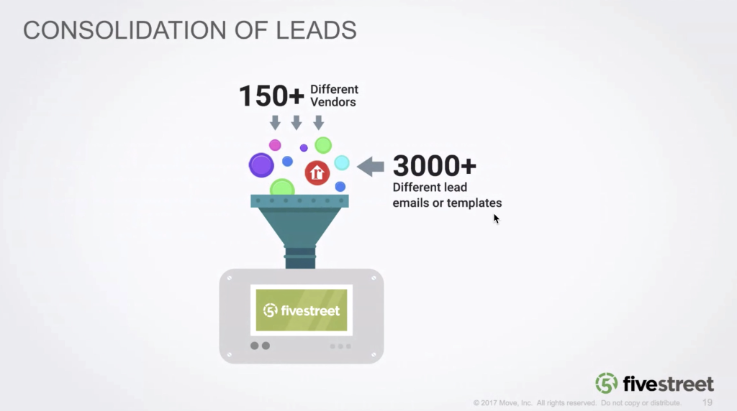

Advantages of using Fivestreet

* Fivestreet sends response to the consumer quickly.
* It helps to connect with the consumer.
* Agent can modify the text message template.
* 90% of the text messages are read in the 3 minutes.
* 65% of leads are claimed within 10 minutes.
* Helps to get good reputation of brokerage with consumer.

**Workflow of FiveStreet Leads**

* When leads are arrived they are broadcasted to all the brokers/agents via messages and emails based on the forwarding rules.
* Anyone can claim the lead, once claimed, the agent who claims the lead gets full information about the lead like customer online profile, property information, inquiry history, routing history.
* If broker team wants, they can assign the lead to other agent.
* As soon as the lead is claimed the customer will get the response via text messages. The agent can change the template of the text message.
* If no one claims the lead the lead is rebroadcast to Ryan based on rebroadcast rule.
* Response is sent to customer through the unique phone number of an agent, so the customer can contact agent.
* Fivestreet will show the team, who has claimed the lead.

We have different sections (Tabs) inside fivestreet.

* Overview
* Leads
* Lead Source
* Team
* Response
* Forwarding
* Account
* Reporting

**Overview**

It tells us from where are the leads coming from i.e the source of the leads. How the leads are performing.

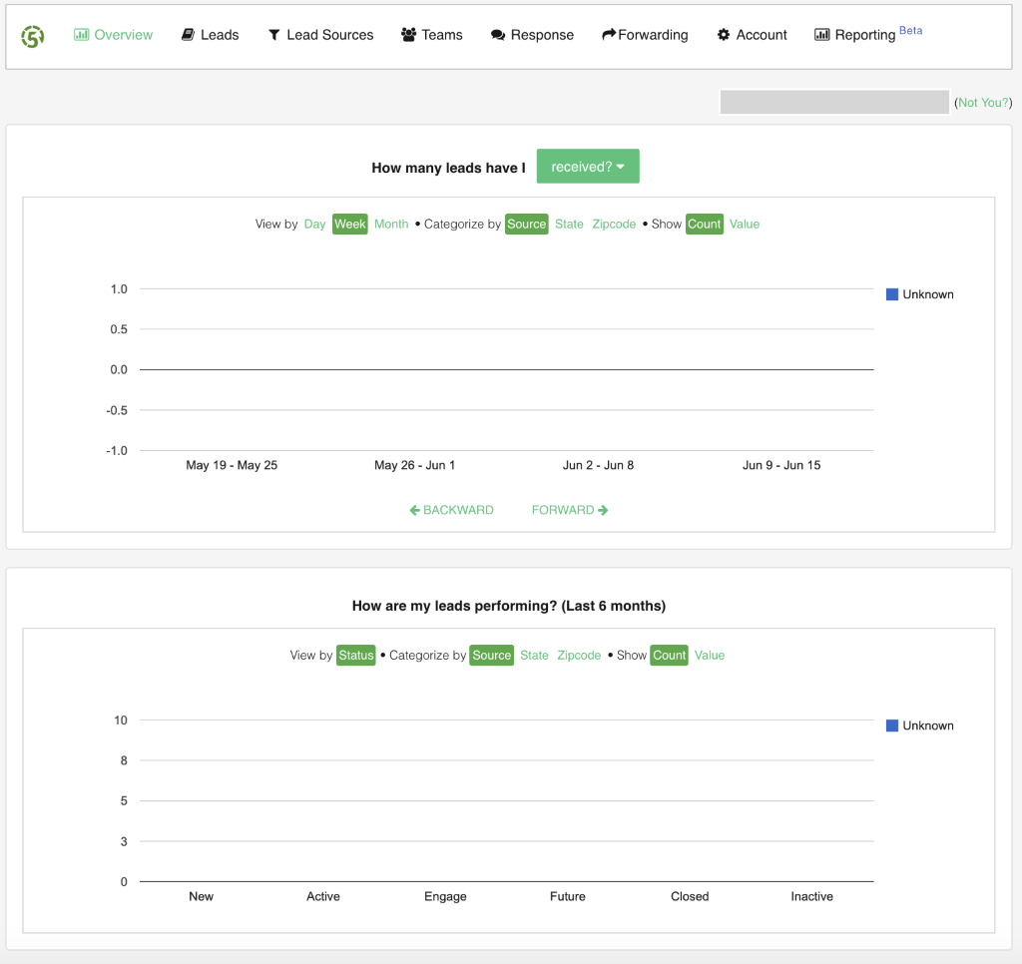

To show the overall leads states.

**Leads**

This gives the information of the customer, online profile, property information, inquiry history, routing history.

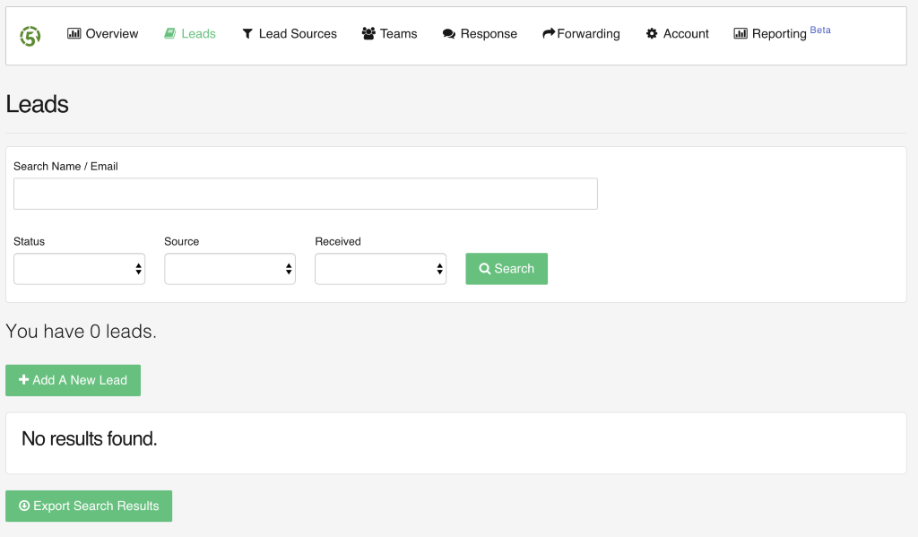

Leads can be searched and can be created manually.

**Lead Source**

Here user need to link the Google account .

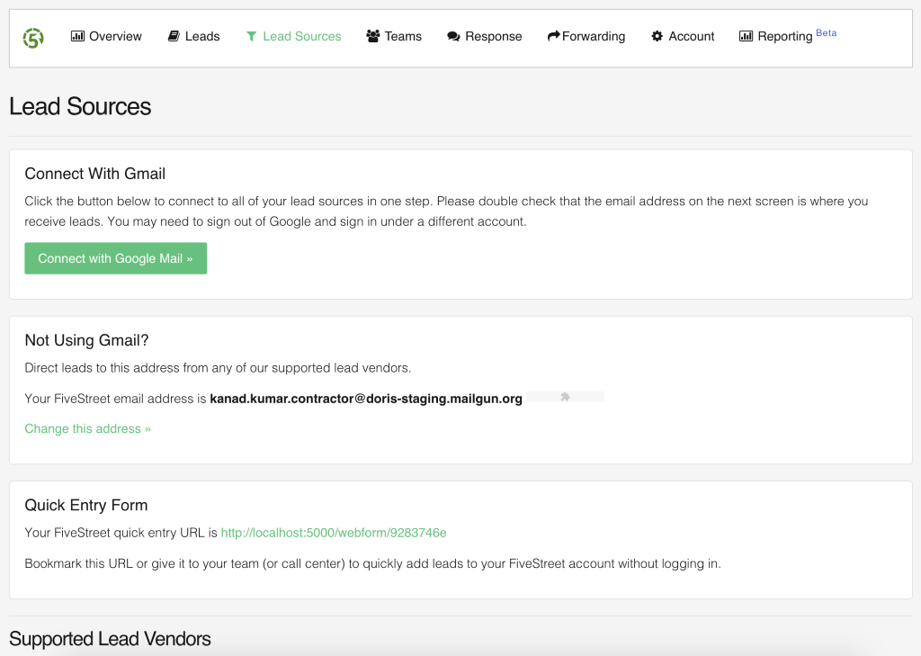

**Team**

In team section we will manage teams and members also we can add and remove members from the list.

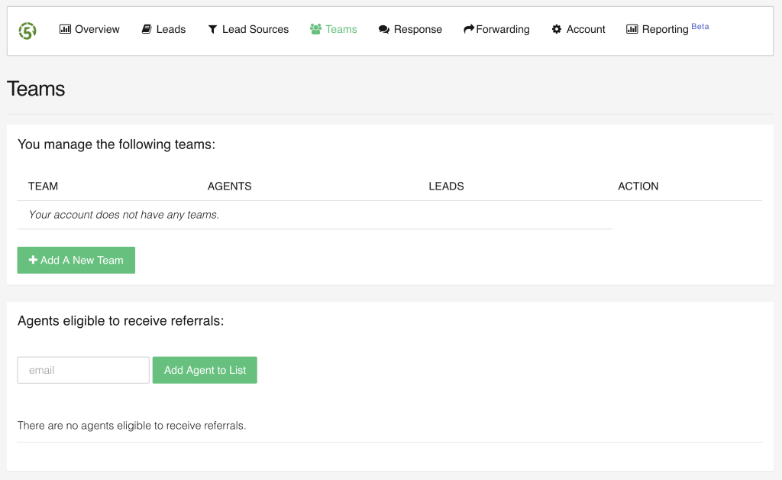

**Response**

This has the Email responder and Text message responder by which the fivestreet sends online leads.

Each agent/broker will have a unique phone number to which the leads are directed to and Trulia is the service provider for this text messages.

Consumer can contact through phone number and the call will be routed to respective agent

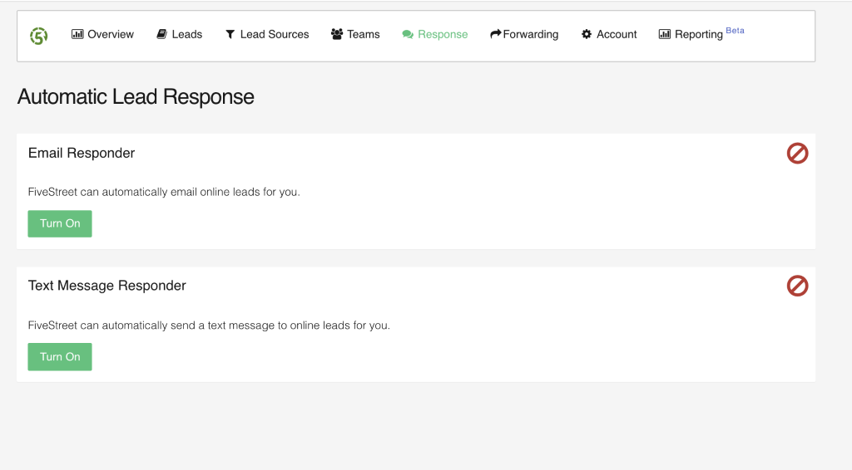

Forwarding

* Broadcast rule : Leads are forwarded to Ryan.
* Listing Agent rule : Giving first chance to particular team before forwarding lead to other teams.
* Source Rules : Turns on source rules, Turns off the zip code rule.
* Zip code Rules : Turns on zip rules, Turns off the source rule.
* Price rules : Forwards leads to team based on the price of the property.
* Rebroadcast Rule : Rebroadcast the lead to Ryan if no one claims them within 20 minutes.
* Team Size Optimizer : We can set the team size , to only that number of agents fivestreet will forward the leads.
* Lead Forwarding Office Hours : Allows to set time period when team will be expected to claim leads.
* Claimed Agent Notifications : Fivestreet will show the team, who has claimed the lead.

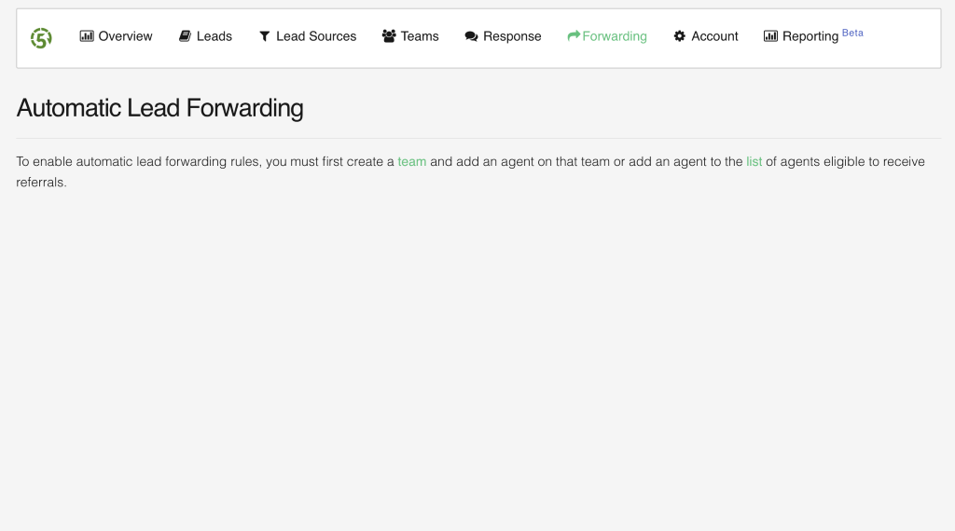

Account

Helps fivestreet to connect with popular marketing tools.

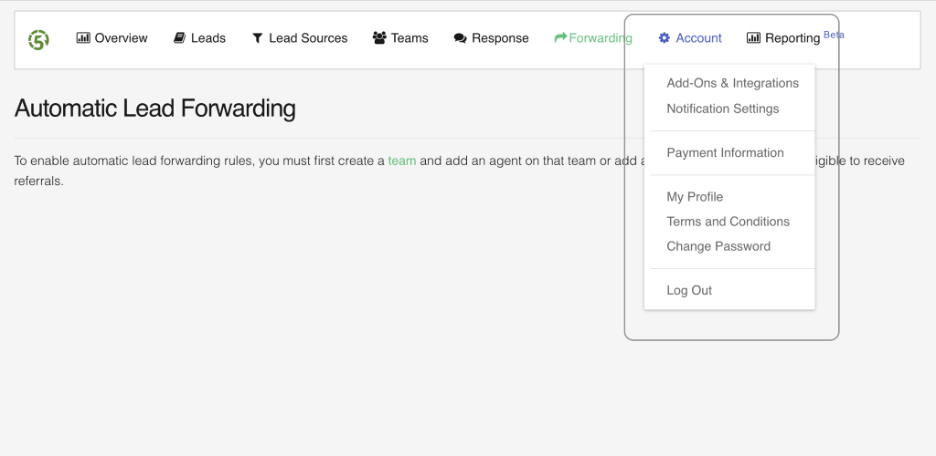

* Add-Ons & Integrations

These are the various marketing tools to which the fivestreet can connect to.

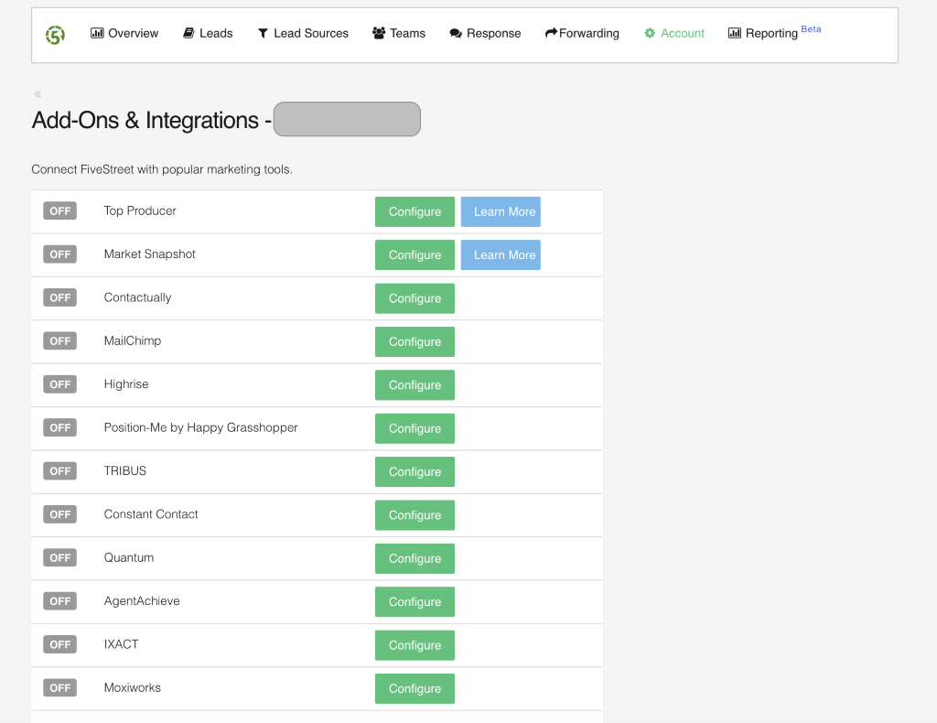

Here Fivestreet user can integrates listed Add-Ons here.

* Top Producer

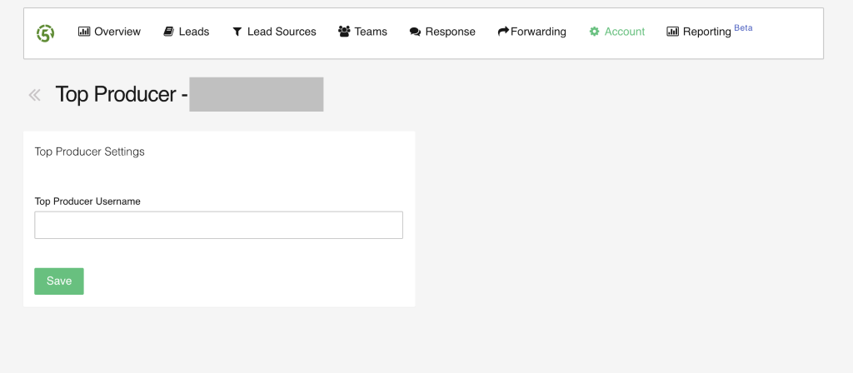

* Market Snapshot

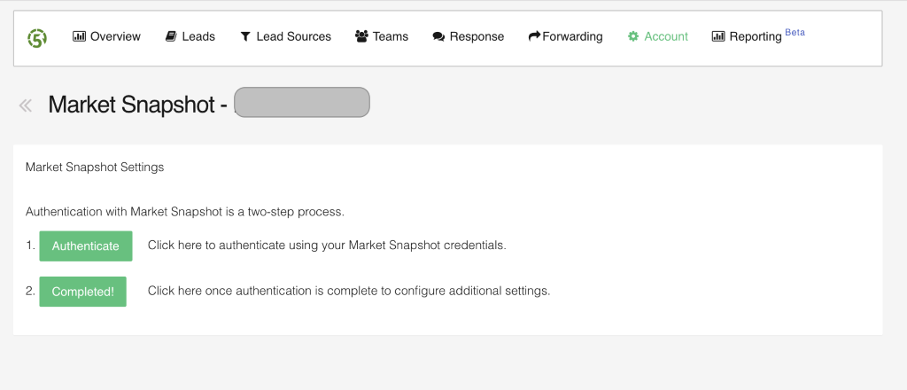

* MailChimp

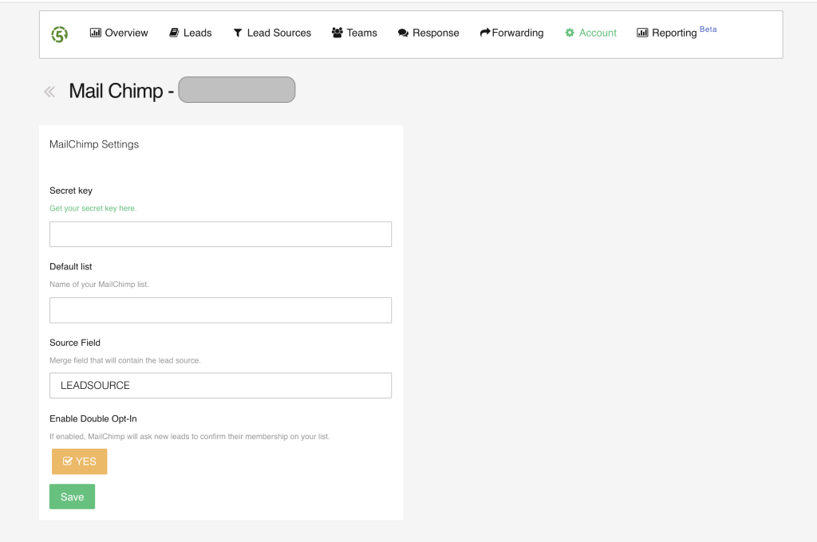

* Highrise

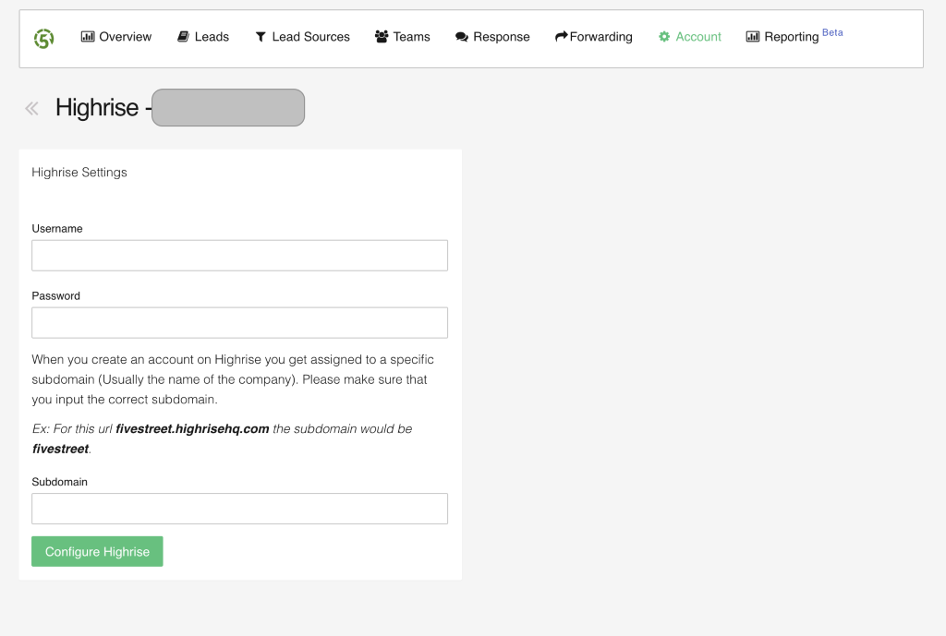

* Position-Me by Happy Grasshopper

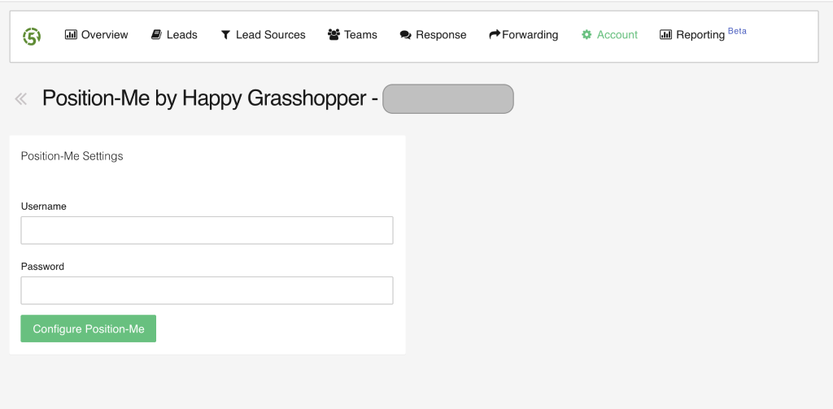

* TRIBUS

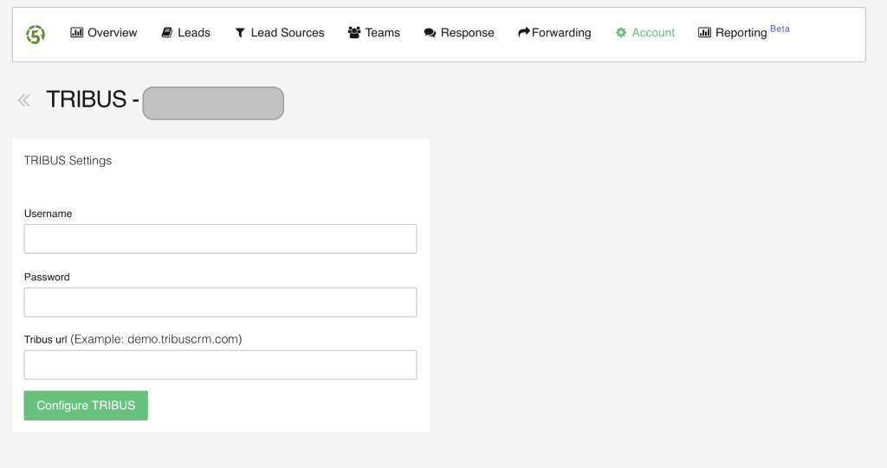

* Constant Contact



* Quantum

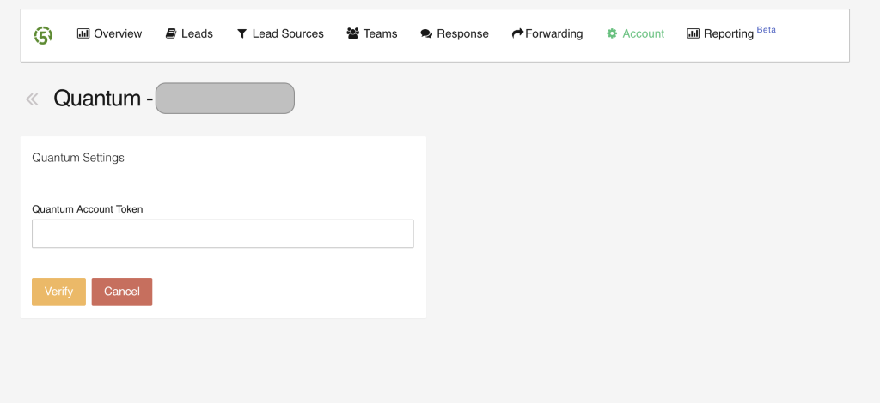

* **AgentAchieve**

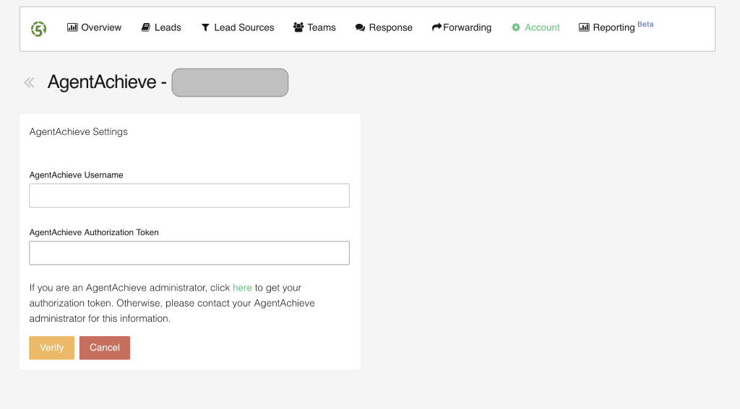

* IXACT

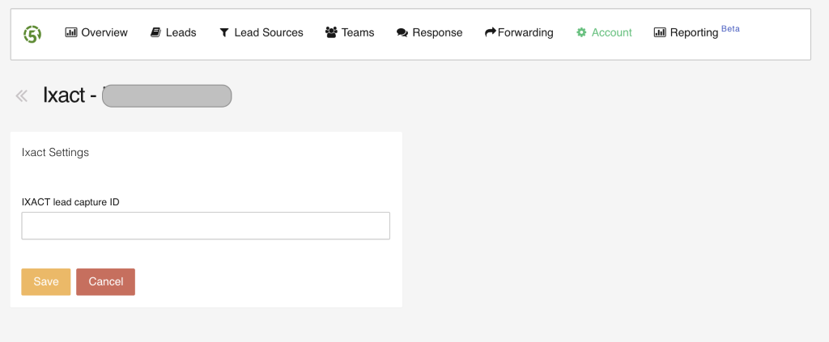

* Moxiworks

